Assignment 3
Adeeba Nizam
Report file Q3
Modified the standard insertion sort algorithm so that it works on a linked list of integers instead of a vector.
Insertion sort normally works on arrays/vectors, but the logic can be adapted to linked lists by inserting each node into a new sorted list.
This implementation meets all assignment instructions:
✔ Uses header (.h) and implementation (.cpp) files
✔ Uses functions and methods only (no inline logic in main)
✔ Code is fully commented
✔ Uses a Linked List as required

1. insertion_sort.h
This header file contains:
- The Node structure
- Function declarations:
  - sortedInsert()
  - insertionSort()
  - appendNode()
  - printList()
The header contains no implementations, only function prototypes, as required.

2. insertion_sort.cpp

This file contains full implementations:
- Node constructor
- sortedInsert()
Inserts a node into the correct sorted position in a sorted linked list.
- insertionSort()
Takes an unsorted linked list and builds a new sorted list by repeatedly inserting nodes.
- appendNode()
Adds a new node to the end of the linked list.
- printList()
Prints all elements in the list.
All functions are well-commented to explain each step.
3. main.cpp
Used only for testing.
It:
- Creates a linked list
- Adds values
- Prints the original list
- Calls the insertion sort function
- Prints the sorted list

3. How the Algorithm Works
Insertion sort on a linked list works differently from arrays:
- Start with an empty sorted list.
- Take the first node from the original list.
- Insert it into the correct position inside the sorted list.
- Repeat for every node.
- When finished, the sorted list replaces the original list.
Since linked lists cannot shift elements like vectors, each item must be placed by repointing pointers, not by copying values.
4. How to Compile and Run the Program

Compile:
Use g++:
g++ main.cpp insertion_sort.cpp -o q3

Run:
./q3

5. Sample Output
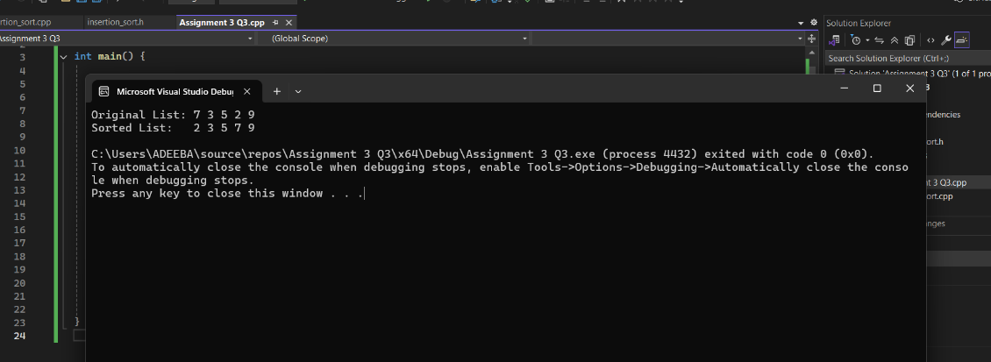
- The sorting is done without arrays or vectors.
- No global variables are used.
- Only linked list operations are used.
- The code follows clean structure and assignment rules.

